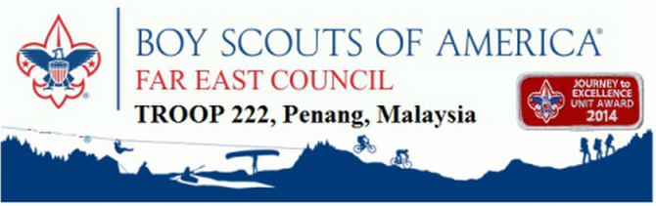
Tanjung Bunga,
11200 Penang, Malaysia
Email: troop222penang@gmail.com
Website: www.bsa-troop222.weebly.com

Dear______,

As representatives of Troop 222 Penang, we are in the need of ordering the following:

- Merit Badges
  - __ (amount and merit badge)
  - __
  - __

The total costs of the merit badges are calculated below:

- __Merit Badge:
  - Individual Cost: $0.00
  - Quantity needed: _
  - Total Price: $0.00 x _ = ___
- __Merit Badge:
  - Individual Cost: $0.00
  - Quantity needed: _
  - Total Price: $0.00 x _ = ___

Let us know if you have any enquiries.

Thank you,

Mr.____________
Troop Committee Official
Troop 222 Penang, Malaysia

Troop 222 Penang, Malaysia is part of the Far East Council and the program is owned by the BSA
Check out our website at http://bsa-troop222.weebly.com

